Modeling AND SiMULATION OF MagNETIC TRANSMISSION LINES
Muhammad Shamaas
ID # 2018-MS-EE-4


DEPARTMENT OF ELectrical Engineering
UNIVERSITY OF ENGINEERING AND TECHNOLOGY LAHORE

Contents
Abstract 2
Acknowledgements 3
List of Figures 4
List of Tables 4
No table of figures entries found. 4
Abstract 5
Introduction 6
1.1. Nature of Magnetic Materials 6
1.2. Magnetic Losses 10
1.3. Summary 10
2. Magnetic Circuit Modeling 11
2.1. Reluctance Model 11
2.2. Capacitance-Permeance Model 11
2.3. Magnetic Transmission Line Model 13
2.4. Conclusion 15
3. Computational Electromagnetics 16
3.1. Methods for solving Maxwell’s Equations 16
3.2. MEEP 16
4. Simulations for Magnetic Transmission Lines 20
4.1. Wideband Transformer Design 20
4.2. Wideband Transformer Simulation in MEEP 20
4. References 23
5. Appendix 24

Abstract

Acknowledgements

List of Figures
Figure 1: Magnetization vs. Applied Field 9
Figure 2: Hysteresis Loop 10

List of Tables

No table of figures entries found.

Abstract
Magnetic Transmission Line is the dual counterpart of Electric Transmission Line. Its theory, encompasses a diverse range of applications including Transformers, Dynamic Machines, Microwave Generators, Tuners, Couplers, Isolators, Power Dividers etc. Intrinsically, Magnetic Transmission Line is made from a non-conducting magnetic material, with a high permeability. It transmits Magnetic Flux which acts as the Magnetic charge. Time varying magnetic flux results in a Magnetic Displacement Current inside the Transmission Line, which has the units of Volts. This produces a gradient Magnetic Field; with Fields Lines that spread radially outwards. The magnetic voltage due to this Magnetic Field is measured in Amperes. Although, the operation of a Magnetic Transmission Line does not involve electric charges, Magnetic Displacement Current produces an Electric Field with closed Field Lines encircling the Magnetic Transmission Line. Together, the Electric and Magnetic Fields transmit Energy along the direction of propagation. These relations will be modeled using Maxwell’s Equations and magnetic circuits to study the time and frequency domain behavior of Magnetic Transmission Lines. Furthermore, Finite Difference Time Domain Electromagnetic Field Simulations will be carried out in MEEP Simulator for anisotropic, inhomogeneous, non-linear Magnetic Transmission Lines.

Introduction

Magnetic Transmission Lines are designed to transmit electromagnetic energy using strong magnetic fields. They are made of magnetic materials with very high magnetic permeability and a strong affinity for magnetic flux. When an external magnetic field is applied, atomic spins tend to align parallel to it. This large scale cooperation enhances the Magnetic Flux Density inside the magnetic material. When the applied field is varied, the changing Magnetic Flux Density transmits the magnetic information across the magnetic material. This phenomenon is called Magnetic Transmission.
It is important to note that charge carriers are not involved in magnetic communication. Isolated Magnetic charges do not exist and magnetic conduction current can never flow in a Magnetic Transmission Line. Magnetic Transmission is only possible through Magnetic Displacement current. This results from the alignment of magnetic dipoles in response to a stimulating Magnetomotive Force.
Moreover, Magnetic Transmission Lines do not involve the flow of Electric charges. Magnetic materials are very poor electric conductors; hence electric currents cannot transmit information across a Magnetic Transmission Line. Changing Magnetic Fields produce Electric Fields which are transmitted through electric displacement currents. This causes polarization of atoms in the dielectric magnetic medium which transmits Electric information across the Magnetic Material. Together, the Electric and Magnetic Fields transmit Electromagnetic Energy along the direction of propagation.
The following sections will elaborate on the subject of Magnetic Materials. A brief account on the losses in Magnetic Transmission Lines will be given as well.

Nature of Magnetic Materials

The basic building blocks of magnetic materials are fictitious magnetic poles which can be considered as magnetic charge carriers. In nature, magnetic monopoles always exist in pairs called magnetic dipoles. A monopole can have either positive or negative charge which is responsible for the magnetic field around it. The force between poles is proportional to the strength of the poles (m) and inversely proportional to the square of distance (r) between them:
$$F∝\frac{m_{1}m_{2}}{r^{2}} (1)$$
Magnetic dipole results from the motion of an electron in an orbit around a nucleus. This is similar to a current flowing in a loop. The identification of the North and South poles is dictated by the Flemming’s right hand rule.
Whenever a moving charge q is placed in an electromagnetic field, it experiences a force called Lorentz Force. The direction of the force represents the direction of least pressure in the electromagnetic field. Lorentz Force depends on the velocity (v) of the charge and the strength of the electric and magnetic fields:
$$F_{m}=q\left(E+v×B\right) (2)$$
If an orbiting electron is placed in a magnetic field, the net Ampere force on the current loop is:
$$F=\oint{Idl×B} (3)$$
The Force will produce a Torque which will rotate the dipole. The Torque can be represented in terms of the magnetic dipole moment (m) normal to the current loop:
$$T=m×B (4)$$
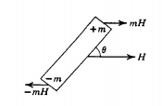
The magnetic dipole moment ($μ$) of an orbiting/spinning electron is proportional to the spectroscopic splitting factor ($g_{s}$) and the associated quantum number (n). It is measured in units of Bohr Magneton ($1μ_{B}=9.274×{10}^{-24}JT^{-1}$).
$$μ=g_{s}n \left(5\right)$$
$$where g=1, n=1 for orbital moment (lowest state)$$
$$g=2, n=\frac{1}{2} for spin moment$$
The net magnetic moment of an atom or ion is the vector sum of the orbital and spin moments of all electrons in its outer shell.
Two dipoles attract each other if unlike poles are close to each other. On the other hand, two dipoles repel each other if like poles are closer. Inside an unmagnetized material, the magnetic dipoles are optimally oriented hence the net torque is zero. Only a few orientations can result in a net zero torque on all the dipoles in a magnetic material. Dipoles tend to align parallel to neighboring dipoles so that the lowest energy state can be achieved.
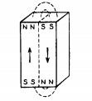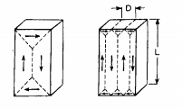
Atoms contain orbitals with discrete levels of energy for accommodating electrons. Electrons try to occupy the lowest energy orbitals first to minimize the energy of the system. An electron with clockwise spin can pair with an electron having anticlockwise spin. Hence, the clockwise spin cancels the effect of anticlockwise spin and no magnetic moment results.
An external magnetic field can cause a mechanical torque on a magnetic dipole. The moment tries to turn the dipole in the direction that decreases the overall energy of the system. Only unpaired spins contribute to the net magnetic moment. The resulting spin and orbital moments add up to produce a net Magnetization Vector Field M inside the magnetic material. This field is proportional to the magnetic susceptibility of the material $(χ_{m}$):
$$M=χ_{m}H ()$$
The Magnetic Field inside a magnetic material can be represented by a flow of magnet field lines. The number of lines passing through a region of space is called Magnetic Flux (equivalent to magnetic charge). Magnetic Flux Density (B) represents the number of flux lines per unit area:
$$B=μ_{0}(H+M) (7)$$
Iron, Nickel and Cobalt contain 4, 3 and 2 unpaired electrons per atom respectively. Hence, the effect of Magnetization is very strong in these special elements and their alloys. Large scale cooperation between magnetic dipoles causes an enhanced Magnetic moment. Due to the high magnetic susceptibility, they are used in the production of Ferromagnetic and Ferrimagnetic materials.
The parallel alignment of magnetic dipoles causes the creation of magnetic domains to reduce the magnetic potential energy stored in the Magnetic Flux Lines. The Magnetic energy consists of the following:
Magnetostatic Energy: The energy needed to place the magnetic poles in a specific geometric configuration e.g. magnetized state. Magnetostatic Energy Density is proportional to the width of the magnetic strip (d) and the value of applied Magnetic Field Intensity (H). The expression is given in (5)
$$E∝dH^{2} (8)$$
Transformers are made using insulated sheets of steel having high electrical resistance. Rolling of the sheets aligns the Magnetic domains and reduces the Magnetostatic Energy.
Magneto-crystalline Anisotropy Energy: For crystalline structures with repeating atomic units, the domain magnetization tends to align along one direction more easily than other directions. Magneto-crystalline Anisotropy Energy is greater in hard direction as compared to the easy direction. It depends on the anisotropy constants ($K_{i}$) and direction cosines ($α_{i}$) which project magnetization on the different axes.
$$E=K_{1}\left(α_{1}^{2}α_{2}^{2}+α_{2}^{2}α_{3}^{2}+α_{3}^{2}α_{1}^{2}\right)+K_{3}\left(α_{1}^{2}α_{2}^{2}α_{3}^{2}\right)… (9)$$
Magnetostrictive Energy: Magnetization and Demagnetization can cause changes in the dimensions of the magnetic materials. These stresses are caused by shifting of atomic planes e.g. during alignment of domains. Magnetostrictive Energy represents the elastic potential energy stored in the constricted atomic configuration. It is proportional to the magnetostriction constant ($λ$) and applied stress ($σ$).
$$E∝\frac{3}{2}λσ (10)$$
Domain Wall Energy: A Domain wall is a region where the Magnetization in one domain gradually changes to the direction of a neighboring domain. Domain Wall Energy represents the energy in the transition region. It is related to Anisotropy Constant ($K_{a}$), Curie Point ($T_{c})$ and atomic spacing (a).
$$E∝\sqrt{\frac{K_{a}T_{c}}{a}} (11)$$
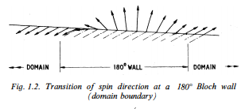
Naturally, the size and direction of magnetic domains is chosen to minimize the overall magnetic energy of the system. If an unmagnetized material is placed in an external magnetic field, the domains may have to align in a hard direction for Magnetization of the material. Work will be done to align the domains in the special configuration so that the preferable domains grow in size while the unfavorable domains shrink. This will involve displacement of atomic planes and domain boundaries. Hence the overall stored magnetic energy of the system will increase during magnetization.
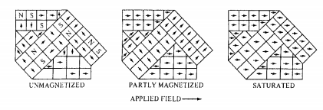
When a demagnetized material is placed in an increasing Magnetic Field, the domain walls will start reversible movements and rotations. The Magnetization will start to increase slowly as shown in the Figure below. This corresponds to the elastic phase with minimum magnetic susceptibility. Later on, the domain wall motions increase greatly. Large scale irreversible atomic plane displacements correspond to the partial magnetism phase in magnetization curve. During this phase, the material exhibits the highest magnetic susceptibility. Soon the majority of domains get aligned with the magnetic field. In the last phase, a large amount of energy is needed to rotate the remaining domain magnetization hence the material exhibits a saturating magnetic susceptibility. At high fields, the induction saturates at Bmax.
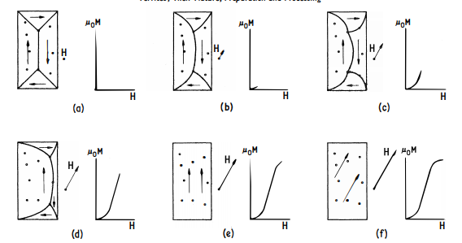
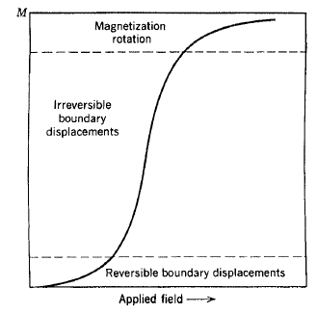
Figure 1: Magnetization vs. Applied Field
If the applied field of the saturated material is decreased, the magnetic domains start to reverse their direction. Initially, the material exhibits a small magnetic susceptibility. This resistance results because the majority of domains are aligned in the easy direction. The favorable domains had shrunk during the magnetization. Work must be done to expand the favorable domain walls in the reverse direction. As a result, demagnetization does not follow the curve of the original magnetization. When the applied field is decreased further, the magnetic susceptibility of the material starts to increase as more domains start to align in the reverse direction.
The induction lags the applied field hence some remnant induction remains when applied field is reduced to zero. In order to demagnetize the material, some extra amount must be applied. This amount is called the coercive force. As the field keeps decreasing, the domains start aligning in the hard direction. Once all the domains have aligned, the material saturates in the reverse direction.
If the material is now magnetized again, the response will contain all the phases described earlier. The induced field will start to increase slowly, followed by a phase of large magnetic susceptibility and end by saturating. Hence magnetization and demagnetization result in a hysteresis loop.
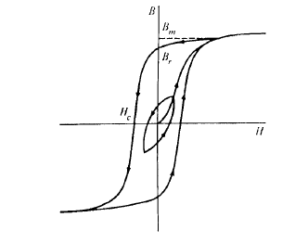
Figure 2: Hysteresis Loop
The slope of the B-H curve is called permeability. It is closely related to the magnetic susceptibility $χ_{m}$.
$$μ=\frac{B}{H}=μ_{0}\left(1+χ_{m}\right) (12)$$
When the material is saturated, the magnetic susceptibility becomes zero. Hence the permeability reduces to $μ_{0}$. Besides Magnetic Field Intensity, permeability is strongly dependent on chemical composition, crystal structure, stress, temperature and time after magnetization.

AC Losses in Magnetic Materials

The cyclic magnetization of a Magnetic Material causes many energy losses. The atomic plane displacements and domain wall rotations cause mechanical losses in the material. Induced voltages cause circulating currents and electrical losses. At microwave frequencies, magnetic resonance and complex permeability can cause a significant increase in the losses. The various loss mechanisms are:
Hysteresis Losses: During the traversal of magnetization loop, energy is lost as heat during irreversible domain changes. The permeability changes with position, the applied field strength, time after demagnetization (disaccommodation), frequency and temperature. Fields inside Anisotropic media can be represented by a 3$×$3 permeability/ magnetic susceptibility tensor:
$$\left[\begin{matrix}B_{x} \\ B_{y} \\ B_{z}\end{matrix}\right]=\left[\begin{matrix}μ_{xx} & μ_{xy} & μ_{xz} \\ μ_{yx} & μ_{yy} & μ_{yz} \\ μ_{zx} & μ_{zy} & μ_{zz}\end{matrix}\right]\left[\begin{matrix}H_{x} \\ H_{y} \\ H_{z}\end{matrix}\right] ()$$
This hysteresis loss is equal to the area inside the DC hysteresis loop:
$$W_{H}=\int{B}dH ()$$
Hysteresis loss increases with the applied field strength and frequency. The empirical formula for Hysteresis Loss Density is:
$$P_{H}∝B_{max}^{n}f ()$$
Eddy Current Losses: Ferromagnetic materials are semiconductors with resistivity ($ρ$) ranging from 0.1Ωm to greater than 1MΩm. The associated permittivity causes dielectric losses. Whenever a changing electromagnetic field is impressed induced voltages are developed in the material. These generate circulating eddy currents in the material and produce Ohmic losses.
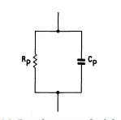
These losses can be reduced by using thin laminated magnetic films or magnetic grains for manufacturing. The Eddy current losses depend on the shape and size (d) of the material, the frequency (f), the applied field intensity ($B_{max}$) and the resistivity ($ρ$) or conductivity ($σ=\frac{1}{ρ}$). The empirical formula for Eddy Current Loss Density is:
$$P_{e}∝\frac{{\left(B_{max}fd\right)}^{2}}{ρ} ()$$
The Eddy Current Losses can be enhanced at high frequencies due to dimensional resonance. If a dimension of the magnetic material is equal to a quarter multiple of the electromagnetic wavelength, a standing wave can develop inside it. Under this condition, the in-phase flux cancels the anti-phase flux so the observed permittivity and permeability drops to zero. The resulting Eddy Current loss shows a peak during resonance. We can represent complex permittivity and complex permeability as:
$$ε=ε_{0}(ε^{'}-j{(ε}^{''}+\frac{σ}{ω})) ()$$
$$μ=μ_{0}\left(μ^{'}-jμ^{''}\right) ()$$
The real part is responsible for the displacement current, whereas the imaginary part contributes to the conduction current. During Dimensional Resonance, the electric conductance of the magnetic material increases greatly. Hence the material acts like an electric conductor with a very low resistivity. Although Magnetic conduction currents do not exist, Magnetic displacement currents can flow inside a magnetic material. When the real permeability drops, the magnetic displacement currents are restricted and the magnetic susceptibility falls. This causes failure of the magnetic system. The associated loss tangents are:
$$tanδ_{d}=\frac{ε^{''}}{ε^{'}} ()$$
$$tanδ_{m}=\frac{μ^{''}}{μ^{'}} ()$$

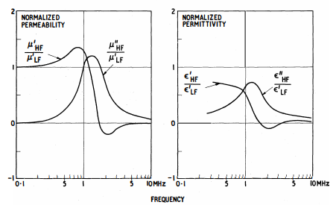
Residual Losses: Besides hysteresis loss and eddy current loss, several processes can contribute to losses when the eddy currents are negligible and the applied flux density is extremely small. These stray losses are independent of the flux density but they increase with frequency. The associated loss tangent is $tanδ_{r}$.
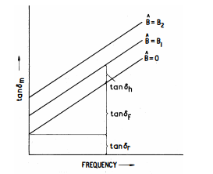
The total loss tangent due to hysteresis loss, eddy current loss and residual loss is:
$$tanδ_{m}=tanδ_{H}+tanδ_{E}+tanδ_{r} ()$$
In conclusion, the three types of losses can be expressed as heat losses across an effective resistance or conductance.

Literature Review

Outline

Wave Propagation in Magnetic Materials

The propagation of electromagnetic waves is governed by the Maxwell’s Equations:
$$∇×H=J+\frac{dD}{dt} ()$$
$$∇×E=-\frac{dB}{dt} ()$$
$$∇.B=0 ()$$
$$∇.D=ρ_{e} ()$$
These equations can be solved in closed form for linear, isotropic, homogeneous media with zero net free charge. The solution is given by the Helmholtz Equations:
$$∇^{2}E=μσ\frac{∂E}{∂t}+με\frac{∂^{2}E}{∂t^{2}} ()$$
$$∇^{2}H=μσ\frac{∂H}{∂t}+με\frac{∂^{2}H}{∂t^{2}} ()$$
For sinusoidal steady state:
$$∇^{2}E=γ^{2}E ()$$
$$∇^{2}H= γ^{2}H ()$$
$$γ=\sqrt{ω^{2}με-jωμσ}=α+jβ$$
The constant $γ$ dictates the wave propagation in the medium. The constant $α$ represents the loss or attenuation of fields whereas the phase constant $β$ dictates the phase velocity (u) and wavelength (𝜆):
$$u=\frac{ω}{β} ()$$
$$λ=\frac{2π}{β} ()$$
For magnetic materials with very small $σ$,
$$β≈β_{o}\sqrt{μ_{r}ε_{r}} ()$$
$$u≈\frac{u_{o}}{\sqrt{μ_{r}ε_{r}}} ()$$
$$λ≈\frac{λ_{o}}{\sqrt{μ_{r}ε_{r}}} ()$$
where $β_{o}$, $u_{o}$ and $λ_{o}$ represent the free space phase constant, phase velocity and wavelength respectively.

The power flow density is given by the Poynting vector:
$$S=E×H ()$$
The flow of Poynting flux can be separated into the Ohmic Power dissipation, Electric Power flow and Magnetic Power flow:
$$-\oint{S.dS}=\int{E.J dV}+\int{E.\frac{∂D}{∂t} dV}+\int{H.\frac{∂B}{∂t} dV} ()$$
From these expressions, it is clear that the Electric Energy and Magnetic Energy of a system is:
$$W_{e}=\int{D.E dV} ()$$
$$W_{m}=\int{B.H dV} ()$$

Magnetic Circuit Modeling

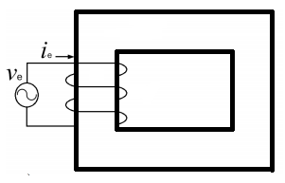

Reluctance Model

H. A. Rowland’s Law (1873) is the counterpart of G. Ohm’s Law (1827) for Magnetic circuits. Complex Reluctance Model defines Magnetic reluctance as the ratio of sinusoidal Magnetomotive Force and sinusoidal Magnetic Flux.
$$R_{m}=\frac{F_{m}}{ϕ_{m}}=\frac{\oint{H.dl}}{\iint{B.dS}}=|R_{m}|e^{j∅} ()$$
Lossy Complex Magnetic Reluctance is non-linear and varies with the magnetic field. It resists both Magnetic flux and changes in Magnetic flux.
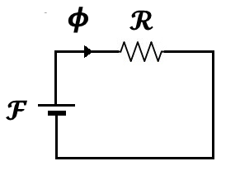
In 1969, R. W. Buntenbach proved that the Reluctance model is not power invariant. Reluctance Power Loss cannot be calculated using Joule Heating Law (1842) analogy due to dimensional inconsistency:
$$[P_{e}]=\left[I_{e}^{2}\right]\left[R_{e}\right]=Ampere.Volt$$
$$but$$
$${[P}_{m}]≠\left[ϕ_{m}^{2}\right]\left[|R_{m}|\right]=Volt.Second.Ampere$$
Hence this is not an accurate model for Power and Energy Flow.

Capacitance-Permeance Model

B. Tellegen’s Gyrator theory (1948) can describe power invariant transformation of magnetic and electric quantities. The dual effort and flow quantities are related by the gyration constant (N). R. W. Buntenbach proposed Power Invariant Permeance-Capacitance Model (1969) to replace Reluctance Model.
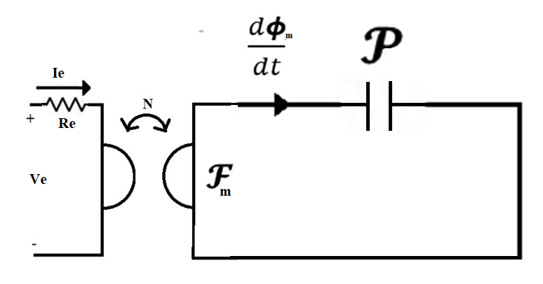
Magnetic Displacement Current is the rate of change of Magnetic Flux which results from the polarization of Magnetic Dipoles. For a magnetic core, the magnetic current and Magnetomotive Force are given by:
$$I_{m,disp}=\frac{dϕ_{m}}{dt}=-\frac{1}{N}V_{e} [Volt] ()$$
and
$$V_{m}=F_{m}=NI_{e} [Ampere] ()$$
Magnetic Permeance is defined as:
$$P_{m}=\frac{ϕ_{m}}{F_{m}}=\frac{\iint{B.dS}}{\oint{H.dl}}=μ\frac{A}{l} [Henry] ()$$
This represents an equivalent magnetic capacitor which stores magnetic charge (magnetic flux).
M. Faraday’s Law (1831): Electric Voltage is responsible for producing Magnetic Current (rate of change of magnetic flux).
$$V_{e}=-N\frac{dϕ_{m}}{dt} ()$$
$$\oint{E.dl}=-\frac{d}{dt}\iint{B.dS} ()$$
A. Ampere’s Law (1861): Magnetic Voltage is responsible for producing Electric Current (rate of change of electric flux).
$$F_{m}=N\frac{dϕ_{e}}{dt} ()$$
$$\oint{H.dl}=\frac{d}{dt}\iint{D.dS} ()$$

Magnetic Transmission Line Model

J. A. B. Faria and M.P. Pires presented Magnetic Transmission Line Model (2012) based on Electric Transmission Line Model in terms of per unit length transverse Impedance and per unit length Longitudinal Admittance.
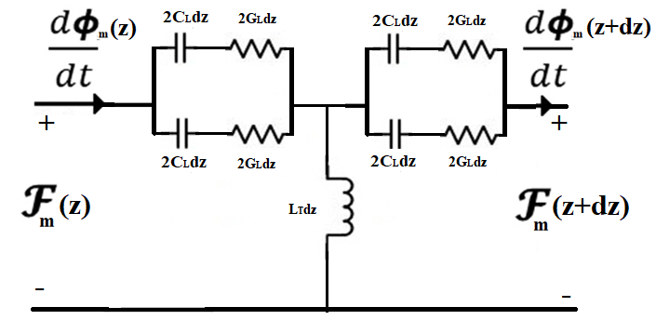
Per unit length Magnetic Conductance, Magnetic Inductance and Magnetic Capacitance are defined as:
$$G_{m}=\frac{F_{m}}{I_{m}}=\frac{\oint{H.dl}}{\oint{E.dl}} [Ohm/m] ()$$
$$L_{m}=\frac{ϕ_{m}}{F_{m}}=\frac{\iint{B.dS}}{\oint{H.dl}} [Henry/m] ()$$
$$C_{m}=\frac{ϕ_{e}}{I_{m}}=\frac{\iint{D.dS}}{\oint{E.dl}} [Farad/m] ()$$
Energy is dissipated in Magnetic Conductance due to skin effect.
$$P_{loss}=I_{m}^{2}G_{m} ()$$
Electrical Energy is stored in Magnetic Capacitance; and Magnetic Energy is stored in Magnetic Inductance.
$$W_{e}=\frac{1}{2}{C_{m}V}_{m}^{2}=\frac{1}{2}\iiint{B.H dV} ()$$
$$W_{m}=\frac{1}{2}{L_{m}I}_{m}^{2}=\frac{1}{2}\iiint{D.E dV} ()$$
The Magnetic Transmission Line Equations can be solved just like Electric Transmission Line Equations.

Electric Transmission Line | Magnetic Transmission Line
$$\frac{dI_{e}}{dz}=-GV_{e}-C\frac{dV_{e}}{dt}$$  $$\frac{dV_{e}}{dz}=-RI_{e}-L\frac{dI_{e}}{dt}$$ | $$\frac{dI_{m}}{dz}=-L_{m}\frac{dV_{m}}{dt}$$  $$\frac{dV_{m}}{dz}=-G_{m}I_{m}-C_{m}\frac{dI_{m}}{dt}$$
$$\frac{d^{2}I_{e}}{dz^{2}}=γ^{2}\frac{d^{2}I_{e}}{dt^{2}}$$  $$\frac{d^{2}V_{e}}{dz^{2}}=γ^{2}\frac{d^{2}V_{e}}{dt^{2}}$$ | $$\frac{d^{2}I_{m}}{dz^{2}}=γ^{2}\frac{d^{2}I_{m}}{dt^{2}}$$  $$\frac{d^{2}V_{m}}{dz^{2}}=γ^{2}\frac{d^{2}V_{m}}{dt^{2}}$$
$$V_{e}\left(z\right)={V_{e}}_{i}(0)e^{-γz}+{V_{e}}_{r}(0)e^{+γz}$$  $$I_{e}\left(z\right)={I_{e}}_{i}\left(0\right)e^{-γz}-{I_{e}}_{r}(0)e^{+γz}$$ | $$V_{m}\left(z\right)={V_{m}}_{i}(0)e^{-γz}+{V_{m}}_{r}(0)e^{+γz}$$  $$I_{m}\left(z\right)={I_{m}}_{i}\left(0\right)e^{-γz}-{I_{m}}_{r}(0)e^{+γz}$$
$$γ=\sqrt{\left(r+jωl\right)\left(g+jωc\right)}$$  $$γ=\sqrt{\left(ρ+jωμ\right)\left(σ+jωε\right)}$$  $$γ=α+jβ$$ | $$γ=\sqrt{\left(jωL_{m}\right)\left(G_{m}+jωC_{m}\right)}$$  $$γ=\sqrt{\left(jωμ\right)\left(σ+jωε\right)}$$  $$γ=α+jβ$$

The generator-receptor Non-Linear Magnetic circuit model is well suited for studying Electromagnetic Interference and Electromagnetic Compatibility of Magnetic Transmission Lines.
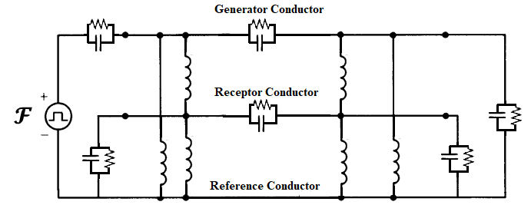

Conclusion

 | Reluctance Model | Permeance-Capacitance Model | Transmission Line Model
Conserved Quantity | ? | Magnetic Flux  [Volt-Second] | Magnetic Flux  [Volt-Second]
Flow Variable | Magnetic Flux  [Volt-Second] | Rate of change of Magnetic Flux [Volt] | Rate of change of Magnetic Flux [Volt]
Effort Variable | Magnetomotive Force [Ampere] | Magnetomotive Force [Ampere] | Magnetomotive Force  [Ampere]
Energy Dissipation Element | Magnetic Reluctance [${Henry}^{-1}$] | ? | Magnetic Conductance  [Ohm]
Electrical Energy Storage Element | ? | ? | Magnetic Capacitance  [Farad]
Magnetic Energy Storage Element | ? | Magnetic Permeance  [Henry] | Magnetic Inductance  [Henry]

Computational Electromagnetics

Solving Maxwell’s Equations

Analytical Methods

Separation of Variables
Conformal Transformation

Numerical Methods (Low Frequency Methods)

Integral Equation (IE) based Methods: Method of Moments (MoM), PEEC, Fast Multipole Method (FMM)
Partial Differential Equation (PDE) based Methods: Finite Element Method (FEM), Finite Difference Time Domain Method (FDTD), FIT, TLM, FVTD

Asymptotic Methods (High Frequency Methods)

Geometric Optics (GO): GTD, UTD
Physical Optics (PO): PTD, UAT

Hybrid Methods

Numerical Method cum Numerical Method: FEM-MoM
Numerical Method cum Asymptotic Method: MoM-PO/ GTD/ PTD

MEEP

MEEP (2006) is a script based Simulator for modeling the time domain and frequency domain behavior of a variety of arbitrary materials including anisotropic, dispersive, non-linear dielectrics, electric/ magnetic conductors, media with saturable gain / absorption, and gyrotropic media.
- C++ interface: Features variable resolution and normalized units.
- Material Library: Sample data for several materials is provided in libraries for building accurate test structures.
- Current Sources: A wide variety of electric or magnetic current sources can be simulated.
- Derived components: Electric/ Magnetic/ Thermal Energy Density, Poynting Flux etc. can be evaluated.
- Mathematical operations: Averaging, symmetry and integration are allowed in cylindrical and rectangular coordinates.
- Data Visualization: The fields can be printed as image or video files.
- A. Ampere’s Law (1861)
$$∇×H-J_{D}-σ_{D}D=\frac{dD}{dt} ()$$
- M. Faraday’s Law (1831)
$$-∇×E-J_{B}-σ_{B}B=\frac{dB}{dt} ()$$
- J. C. F. Gauss’s Law for Electricity (1813)
$$∇.D=ρ_{e} ()$$
- J. C. F. Gauss’s Law for Magnetism (1813)
$$∇.B=ρ_{m} ()$$
- K. S. Yee’s Method (1966) or Finite Difference Time Domain Method is a differential numerical modeling technique for computational electrodynamics.
- J. C. Maxwell’s Equations (1861) are discretized using central difference approximations to the space and time partial derivatives. For example,
$$∇×H=\left(\frac{∆H_{z}}{∆y}-\frac{∆H_{y}}{∆z}\right)a_{x}+\left(\frac{∆H_{x}}{∆z}-\frac{∆H_{z}}{∆x}\right)a_{y}+\left(\frac{∆H_{y}}{∆x}-\frac{∆H_{x}}{∆y}\right)a_{z} ()$$
$$\frac{∆H_{z}}{∆y}=\frac{H_{z}^{n}\left(x,y+\frac{∆y}{2},z\right)-H_{z}^{n}(x,y-\frac{∆y}{2},z)}{∆y} ()$$
where n represents the discrete time step.
- Finite Difference Time Domain Method discretizes space into a grid of small elements called Yee Lattice (1966). The different field components at a grid location are stored in the edges and faces of a cubic element. They are evolved in discrete time steps.
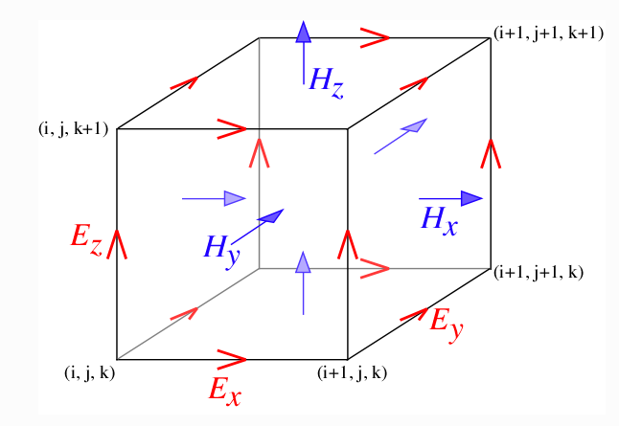
The finite region of space must always be terminated with some boundary conditions. Three types of terminations are supported:
- Bloch-periodic Boundaries: These are used for simulation of periodic structures $f\left(x\right)=f(x+L)e^{-jkL}$. Periodic Bloch Boundaries copy the field component at one cell’s edge and reinject them at a neighboring cell’s edge.
- Metallic Walls: All fields are forced to be zero at the boundaries (perfect reflector has zero absorption and zero skin depth).
- Perfectly Matched Layers: All the fields pass through the open boundary with no reflection. These absorbing boundary layers (ABC) absorb all incident fields.
- $ε(x)$ and $μ(x)$ can vary with position inside a material. They can be declared at each individual point $x$ in space using a function.
- 1-D, 2-D and 3-D simulation is possible. Hence every space vector can have up to three spatial coordinates.
- The simulation can be carried out in rectangular or cylindrical coordinates. Hence different homogeneous/inhomogeneous structures can be built inside the space.
- Symmetry can be used to create complex geometries as well.
- Drude-Lorentzian Model (1900) models frequency dependent permittivity and permeability. Flux Densities contain terms for infinite frequency response and frequency dependent Polarization vector.
$$D=ε_{∞}E+P ()$$
$$B=μ_{∞}H+M ()$$
- $ε$ and $μ$are represented as a sum of harmonic resonances and a term for frequency independent electric conductivity.
$$ε\left(ω,x\right)=(1+\frac{jσ_{D}}{ω})(ε_{∞}\left(x\right)+\sum_{N}{\frac{σ_{n}\left(x\right)ω_{n}^{2}}{ω_{n}^{2}-ω^{2}+jωγ_{n}}}) ()$$
$$μ\left(ω,x\right)=(1+\frac{jσ_{B}}{ω})(μ_{∞}\left(x\right)+\sum_{N}{\frac{σ_{n}\left(x\right)ω_{n}^{2}}{ω_{n}^{2}-ω^{2}+jωγ_{n}}}) ()$$
$σ_{D}/σ_{B}$is the electrical/magnetic conductivity. $σ_{N}$ couples the polarization to the driving field, $ω_{N}$ is the angular resonance frequency, $γ_{N}$ is a damping factor.
- Dispersion Drude-Lorentzian Model (1900) explains the electrodynamic properties of metals by regarding conduction band electrons as non-interacting electron gas.
- When the material is excited by an external source of resonant frequency, the material absorption loss increases greatly. Electromagnetic Energy is converted into other forms of energy.
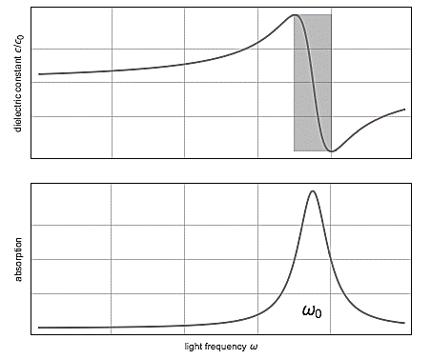
- In Pockels and Kerr Non-linearity model (1875), $ε$ and $μ$can be changed by the field intensity.
$$D=(ε_{∞}\left(x\right)+χ^{\left(2\right)}\left(x\right).diag\left(E\right)+χ^{\left(3\right)}\left(x\right).{|E|}^{2})E+P ()$$
$$B=(μ_{∞}\left(x\right)+χ^{\left(2\right)}\left(x\right).diag\left(H\right)+χ^{\left(3\right)}\left(x\right).{|H|}^{2})H+M ()$$
$χ^{\left(2\right)}$ sum is the Pockels effect; whereas $χ^{\left(3\right)}$ sum is the Kerr effect.
- Ferromagnetic materials are non-linear as their permeability varies with the strength of applied field intensity.
- At high magnetic field intensity, the material saturates, limiting further increase of Magnetic Flux. Hence, the susceptibility decreases rapidly.
- Landau-Lifshitz-Gilbert model (1955) describes the precessional motion of saturated magnetic dipoles in a magnetic field.
$$\frac{dM_{n}}{dt}=b_{n}×\left(-σ_{n}H+ω_{n}M_{n}+α_{n}\frac{dM_{n}}{dt}\right)-γ_{n}M_{n} ()$$
$M_{n}$describes the linear deviation of magnetization from its static equilibrium value. Precession occurs around this unit bias vector $b_{n}$. $σ_{n}$ couples the polarization to the driving field, $ω_{n}$ is the angular resonance frequency, $γ_{n}$ is a damping factor.
- For such anisotropic media, non-diagonal susceptibility tensor is used to relate Magnetization and Field intensity.
$$M_{n}=\left[\begin{matrix}χ_{⊥} & -jη & 0 \\ jη & χ_{⊥} & 0 \\ 0 & 0 & χ_{||}\end{matrix}\right]H ()$$
- G. Green’s Functions (1835) give the Field Patterns from a localized point source at a particular frequency $ω$.
$$G_{ij}(ω;x,x^{'}) ()$$
The point current source $j$ is placed at $x^{'}$. The $i^{th}$ field component is observed.
$$J\left(x\right)=\hat{e_{j}}.e^{-jωt}.δ\left(x-x^{'}\right) ()$$
- A frequency domain solver is also provided for multidimensional Fourier transformation (1822) and the decomposition of fields into travelling modes.
- Broadband response: The 3 Dimensional Discrete Fourier transform (1822) of the response to a short impulse can give useful information about the transmitted power and losses.
- The Transmitted Power can be computed using the integral of Poynting Vector (1884); over a surface on the far end of the transmission line.
$$P\left(ω\right)=Re \left\{\hat{n}.\int{{E_{ω}\left(x\right)}^{*}×H_{ω}\left(x\right)}d^{2}x\right\} ()$$
- Transmitted power and incident power can be used to find power losses in transmission line.

Magnetic Transmission Line Simulation

Wideband Transformer Design

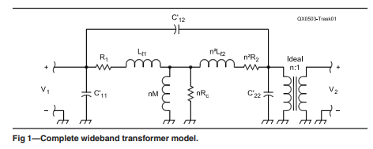
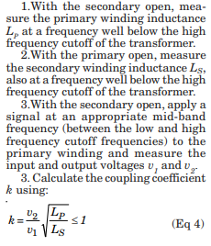

Wideband Transformer Simulation in MEEP

- The Magnetic Transmission Lines will be constructed for inhomogeneous, dispersive, non-linear ferromagnetic conductors like Ferromagnetic, Permalloy and Cobalt alloys.
- The Transmission Lines will be excited using continuous current sources.
- The terminations can be modeled by Perfectly matched layers for complete absorption; or as perfect reflectors for no load.
- Different Transmission Line structures can be simulated like shielded transmission line and multi-wire transmission lines.
- The multi-dimensional discrete Fourier transform (1822) and mode decomposition will be used to determine the Absorbance, Transmittance and Broadband Response.
- A wideband transformer passes a frequency band of several decades and are usually designed to handle complex waveforms like rectangular pulses. They are used for impedance matching, voltage/ current transformation, DC isolation, mixing, power splitting, coupling and signal inversion.
- A wideband transformer will be simulated. It will be excited by a small pulse to examine the Frequency Response. The 3 dimensional discrete Fourier Transform will be used to determine Absorbance, Transmittance and Broadband Response. The results can be compared with published datasheet.

The Loss tangent $tanδ$ has the following components:
- DC Resistance Loss Tangent $tanδ_{dc}$
- Skin Effect Loss Tangent $tanδ_{se}$
- Proximity Effect Loss Tangent $tanδ_{pe}$
- Self Capacitance Dielectric Loss Tangent $tanδ_{cp}$
- Self Capacitance Circulating Currents Loss Tangent $tanδ_{cs}$
- Core Residual Loss Tangent $tanδ_{r}$
- Core Eddy Current Loss Tangent $tanδ_{f}$, $P_{e}=\frac{{(πfτB_{max})}^{2}V}{6ρ}$
- Core Hysteresis Loss Tangent $tanδ_{h}$, $P_{h}=ηVfB_{max}^{n}$
Non-linear components must be used for these complex effects. Network Equivalent Magnetic circuits and coupled equations will be used to simplify analysis of the transient and steady state behavior.
- Magnetic coupling between magnetic transmission lines results in sharing of electromagnetic energy. This division of power is very useful in design of Radio frequency devices like sensors, antennas and communication systems.
- Magnetic Coupling is also very important in the working of DC and AC machines like induction motor, hysteresis motor and Reluctance motor.
- The study of capacitive/ inductive coupling in Multi-Conductor Transmission Lines will provide useful knowledge about the Radiated/ Conducted Emissions and Radiated/ Conducted Susceptibility.
- The results can be compared with MATLAB linear circuit models for cross talk between Magnetic Transmission Lines.
- The aim will be to minimize Electromagnetic Radiation; that can be picked up by unintentional receivers like digital Computers.
The simulators can not be used to model the following magnetic effects:
- Magnetostriction
- Accoustic effects
- Relativistic Effects
- Magnetohydrodynamics
- Gravitomagnetism
- Optical Effects

Conclusion
The conventional reluctance model is not accurate for the modeling of magnetic circuits. It must be replaced by Magnetic Transmission Line Model for accurate modeling of such inhomogeneous, dispersive, non-linear structures.
The power invariant Magnetic Transmission Line model can also be used for accurate modeling of
- AC and DC Machines
- Micro-strip Antennas
- Gyromagnetic NLTLs
- Magnetic Transistors and Microprocessors

References

Appendix

